Deadline: Feb 1, 2022, 11:59PM CT

Task 1:

Using requests and BeautifulSoup to scrape a static html webpage (if using Python):

<http://yuhenghu.com/ids566.html>

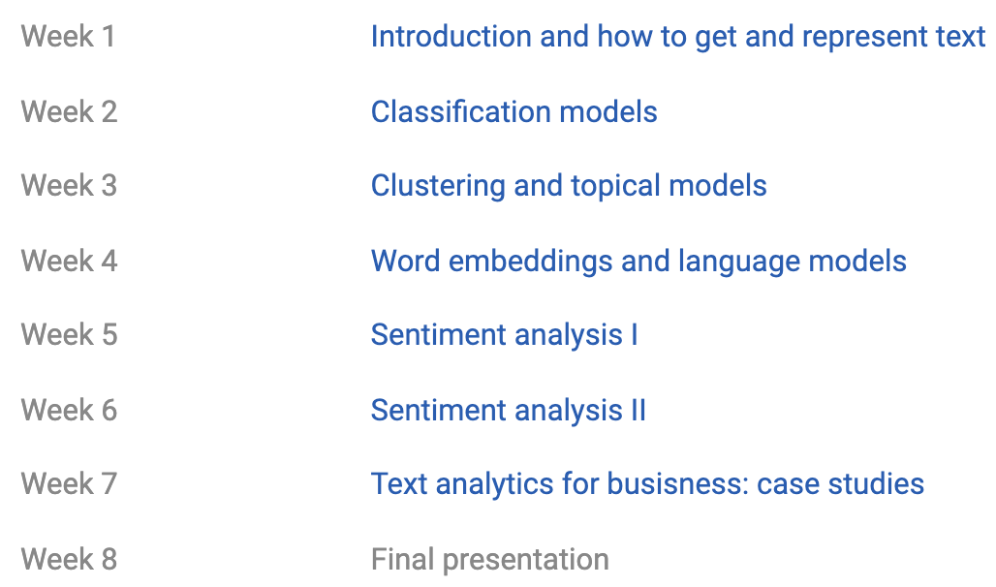

Output:

Week 1<tab>Introduction and how to get and represent text

…

…

Week 8<tab>Final presentation

Task 2:

Using requests and BeautifulSoup and XHR inspection to scrape a dynamic html webpage (if using Python):

<https://www.zillow.com/homedetails/10111-Parish-Pl-Cupertino-CA-95014/19620225_zpid/>

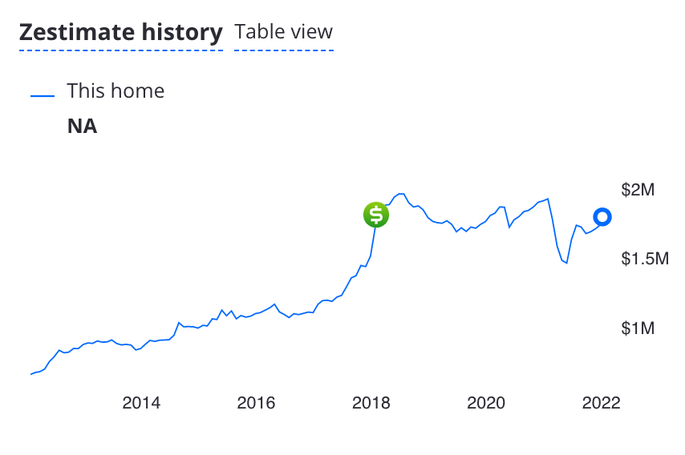

Write a scraper to retrieve data about month/year and price of this home. Sort by the month/year

Output 1:

|  |  |
| --- | --- |
| 1/2012 | 662835 |
| 2/2012 | 676508 |
| 3/2012 | 683436 |
| 4/2012 | 701710 |
| 5/2012 | 757372 |

…

|  |  |
| --- | --- |
| 10/2021 | 1692700 |
| 11/2021 | 1714100 |
| 12/2021 | 1742400 |
| 1/2022 | 1737000 |

In addition, also plot the price vs. month/year. Here’s my plot with Google sheet, you can use any tool:

